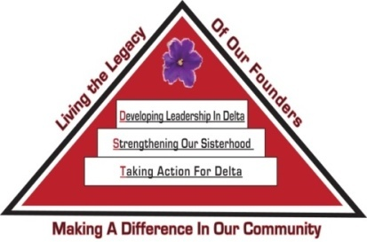 Tampa Alumnae Chapter
Delta Sigma Theta Sorority, Inc.
2nd Vice President Report
March 2020

Archives
- Chair: Soror Tonja Brickhouse tbrick4140@aol.com Properties/Storage sub-committee - Co-chair, Soror Schantel Bobo, tcbfl2000@aol.com
No report at this time.

Nominating Committee
- Chair: Soror DeVonne McKeever-Daniels devonnemc9@gmail.com Co-Chair: Alicia Howell-Banks achowell75@yahoo.com
Reminder: Are you interested in running for office? Applications are due March 21st at 11:59pm.

Grants
- Chair: Soror Tina Fernandez, tfernandez35@gmail.com
No report at this time.

Membership Services
- Chair: Soror TeKeisha Zimmerman Zimmerman.tekeisha@gmail.com
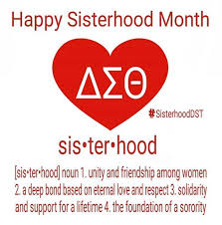
Concerns
- Co-Chair: Soror Wanda Seigler poppye53@gmail.com
Courtesy
- Co-Chair: Soror Leslie Woods-Brown, drbrown427@verizon.net
Delta Connection
- Co-Chair: Soror Theresa Cross tcross499@gmail.com
Hospitality
- Co-Chair: Soror Alicia Howell Banks achowell75@yahoo.com
Social
- Co-Chairs: Soror Jacquelyn Bogen yvonne33617@yahoo.com, Soror Chantelle Harrison chantelle.harrison9@gmail.com
Please contact the sub-committee immediately to notify them of any events you anticipate using their services throughout the sororal year.
Delta Internal Development
- Co-Chair: Soror Nadine Johnson, njdelta40@aol.com
Collegiate Connection
- Co-Chair: Soror Jasmine White-Bynum, jswhiteb@ncsu.edu
Reclamation
- Co-Chairs: Soror Estella Gray estellagray@yahoo.com
Founders Day
- Co-chair: Soror Edith Randolph edithrandolph27@yahoo.com

Technology and Communications Committee
- Chair: Soror Katina Robinson ebonykat@tampabay.rr.com Co-chair –Soror Dioan Johnson, djatlast1913@gmail.com
No report at this time.

Ritual and Ceremonies
- Chair: Soror Janice Crowley crowleyj002@yahoo.com, Soror Joyce Patterson patsjoy127@yahoo.com
No report at this time.

Public Relations
- Chair: Soror Jamel Lanee jlanee1@gmail.com, Co-Chair: Soror Mallory Davis mal.davis1913@gmail.com
The committee asks that requests for publicity be submitted 8 weeks prior to the event so there is ample time to create and implement an appropriate plan.
In February, the committee promoted and created publicity items for the Arts and Letters Book Club, Queen of Hearts Ball and Regional Conference.

Policies and Procedures
- Co-Chair: Soror Tayanna Richardson tqsarichardson@yahoo.com
Report submitted separately.

Protocol and Traditions
- Chair: Soror Imani Coles Imani.coles@spartans.ut.edu, Co-chair: Soror Marian Lauria-Gibson mslauria1@verizon.net
No report at this time.

Strategic Planning
- Chair: Karen Beard, Co-Chair: Tonja Brickhouse
No report at this time.

Audit
- Chair: Soror Gloria Williams glojean29@earthlink.net
No report at this time.

Respectfully Submitted,
Sabrina Griffith, 2nd Vice President

